Study of Dynamic Routing Protocols using GNS3

Objectives:

• To study the routing information protocol.

• To study the open shortest path first.

The RIPv2 routing protocol uses the following command syntax

Router(config)#router rip

Router(config-router)#version 2

Router(config-router)#network <network-IP>

Router(config-router)#network <network-IP>

Ex. No. 1: Configure the below topology to setup connectivity using RIPv2. R1, R2, and R3 will use dynamic routing protocol (RIPv2).

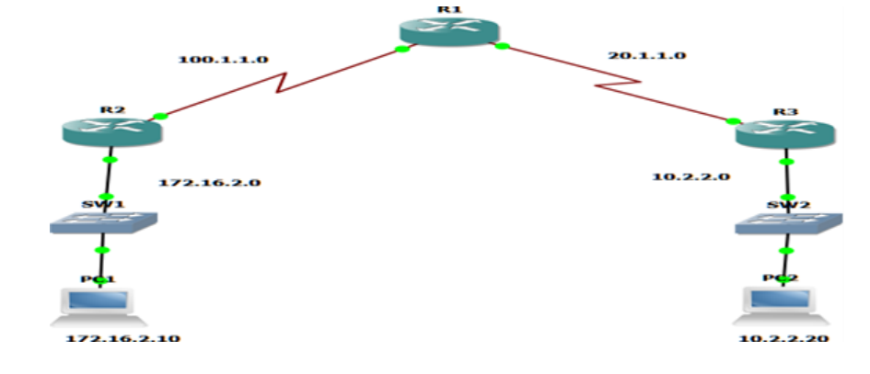

Configuration for R1

R1#conf t

R1(config)#ints1/0

R1(config-if)#ip add 100.1.1.2 255.255.255.0

R1(config-if)#no shut

R1(config-if)#int s1/1

R1(config-if)#ip address 20.1.1.1 255.255.255.0

R1(config-if)#no shut

R1(config-if)#exit

R1(config)#router rip

R1(config-router)#version 2

R1(config-router)#network 20.1.1.0

R1(config-router)#network 100.1.1.0

Configuration for R2

R2#config t

R2(config)#int f1/0

R2(config-if)#ip address 172.16.2.1 255.255.0.0

R2(config-if)#no shut

R2(config-if)#int s2/0

R2(config-if)#ip address 100.1.1.1 255.255.255.0

R2(config-if)#no shut

R2(config-if)#exit

R2(config)#router rip

R2(config-router)#version 2

R2(config-router)#network 172.16.0.0

R2(config-router)#network 100.1.1.0

Configuration for R3

R3#config t

R3(config)#ints2/0

R3(config-if)#ip add 20.1.1.2 255.255.255.0

R3(config-if)#no shut

R3(config-if)#int f1/0

R3(config-if)#ip add 10.2.2.1 255.255.255.0

R3(config-if)#no shut

R3(config-if)#exit

R3(config)#router rip

R3(config-router)#ver 2

R3(config-router)#network 10.2.2.0

R3(config-router)#network 20.1.1.0

RIP Verification:

1. show ip route command should display all RIP networks and end to end ping should be

successful.

1. show ip protocol command should display if necessary, ports are active.
2. show ip rip database command should displays the contents of RIP database inside the router.
3. debug ip rip command shows RIP updates occurring in the system undebug all Once you turn on
4. debug ip rip router will keep showing RIP updates. The command undebug all will stop such RIP updates.
5. show running-config command is used to get the current configuration from the Router.

2. Open Shortest Path First - OSPF

The OSPF routing protocol uses the following command syntax:

Router(config)#router ospf <process id 1-65535>

Router(config-router)network <network address> <wild card mask> area <0-

4294967295>

Area id number can always be zero (0) for small networks, but for larger networks, the area IDs need to be properly planned as all routing updates must traverse area 0

Ex No.2:

Configure the below topology to setup connectivity using RIPv2. R1, R2, and R3 will use

dynamic routing protocol (OSPF)

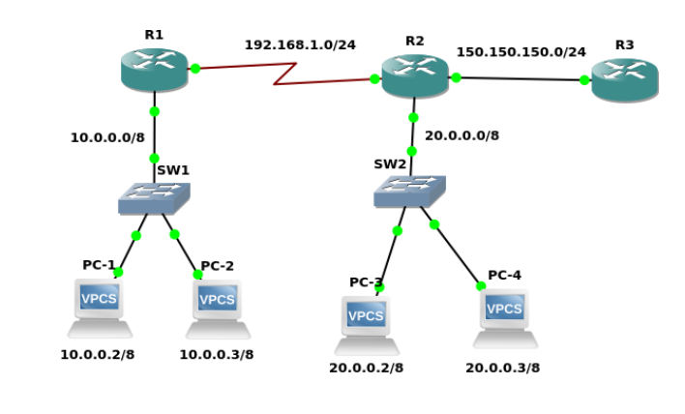

Configuration for R1

R1(config)#router ospf 200

R1(config-router)#network 10.0.0.0 0.255.255.255 area 0

R1(config-router)#network 192.168.1.0 0.0.0.255 area 0.0.0.0

R1(config-router)#exit

Configuration for R2

R2(config)#router ospf 200

R2(config-router)#network 20.0.0.0 0.255.255.255 area 0

R2(config-router)#network 192.168.1.0 0.0.0.255 area 0

R2(config-router)#network 150.150.150.0 0.0.0.255 area 1

R2(config-router)#exit

R2(config)#exit

Configuration for R3

R3(config)#router ospf 200

R3(config-router)#network 150.150.150.0 0.0.0.255 area 1

R3(config-router)#exit

R3(config)#exit

OSPF Verification:

show ip route

show ip ospf neighbor

show ip ospf database